**MATLAB**

PROJECT REPORT



# BACHELOR OF COMPUTER APPLICATIONS

*Submitted To*

**DR TORALIMA BORA**

**CENTRE FOR COMPUTER SCIENCE AND APPLICATIONS, DIBRUGARH UNIVERSITY**

**By**

Chinmoy Gogoi, Roll No:22992154 Dishanta Deka, Roll No: 22992156 Pragyan Chetia, Roll No: 22992182

BCA 4th SEMESTER

**PROJECT TOPIC**

Automatic Certificate Generation Using MATLAB

# Significance of our project

This program is used for generating certificates collecting participant’s data from excel sheets.

This program can help save time and hustles and can arrange and manage certificates in an orderly manner.

Certificates generated by the program can be saved in a folder with a unique filename.

# Modules and libraries used

xlsxread(filename) reads the first worksheet in the Microsoft Excel spreadsheet workbook named filename and returns the numeric data in a matrix.

imread(filename) reads the image from the file specified by filename, inferring the format of the file from its contents. If filename is a multi-image file, then imread reads the first image in the file.

insertText(I, position, text) returns a truecolor image with text inserted. The input image, I, can be a truecolor or grayscale image.

# Procedure

1. Read an Excel sheet containing details. Text is read from the file separately from numbers.
2. Read blank certificate image.
3. Obtain topics from the txt variable which are in 3rd column.
4. Combine names and topics
5. Obtain positions to insert on the image, MSPaint or any image editor.
6. Provide parameters for function insertText.
7. Font size is 50, font style is Arial and opacity of box is 0 means 100% transparent.
8. Generate and save files with .png extension.

# MATLAB Code

clc

clear all

close all

home

filename = 'data.xlsx';

[num,txt] = xlsread(filename)

len=length(txt)

blankimage = imread('certificate.png');

for i=1:len

for j= 2:2

text_names(i,j)=txt(i,j)

end

end

for i=1:len

for j= 3:3

text_topic(i,j)=txt(i,j)

end

end

for i=2:len

text_all=[text_names(i,2) text_topic(i,3)]

position = [487 970;397 1246];

RGB = insertText(blankimage,position,text_all,'FontSize',45,'BoxOpacity',0);

figure

imshow(RGB)

y=i-1

filename=['Certificate' num2str(y)]

lastf=[filename '.png']

saveas(gcf,lastf)

end

**Code Editor**

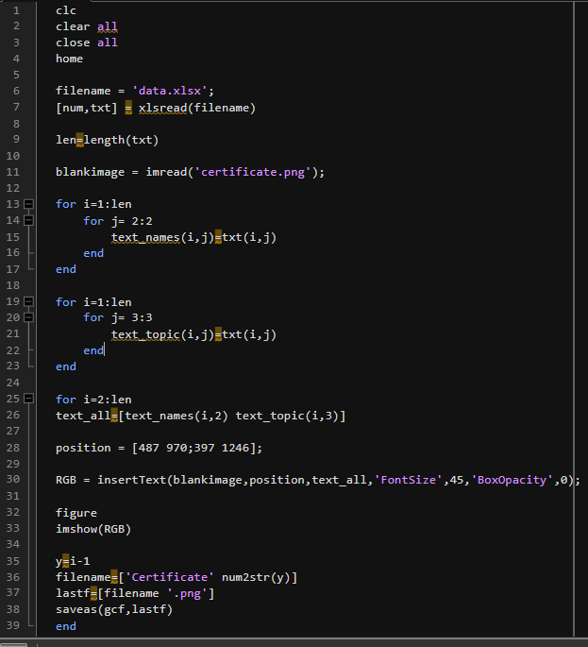

# Command Window

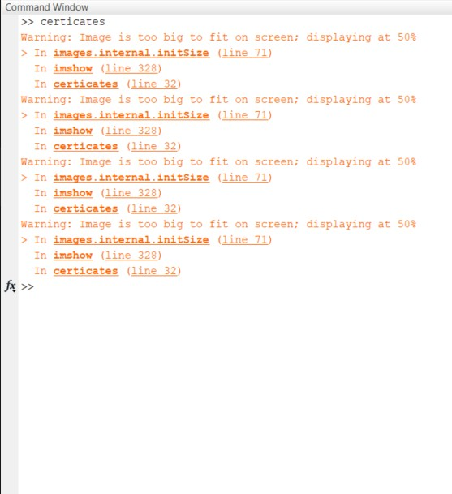

**Provided Inputs**

Excel sheet of certificate details

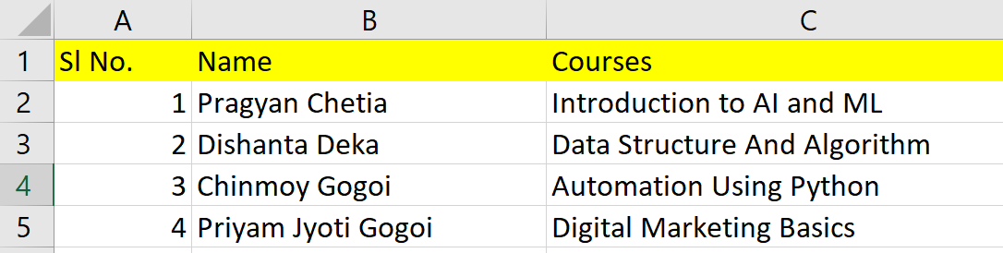

Blank certificate image



# Output

# Generated Certificates

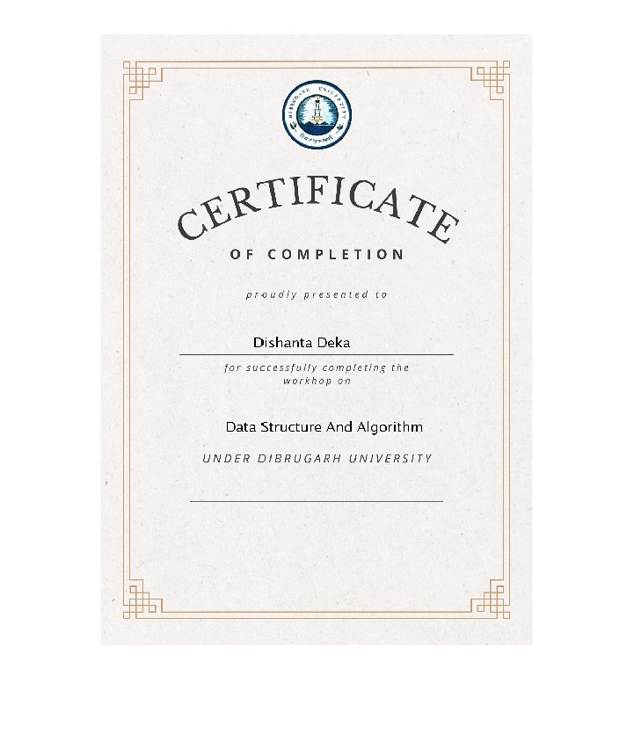

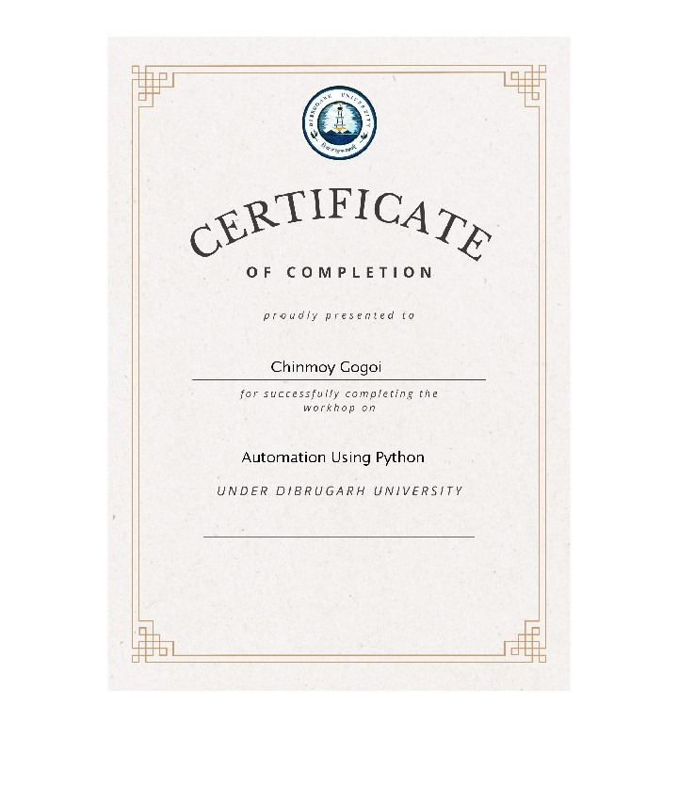

# Workspace

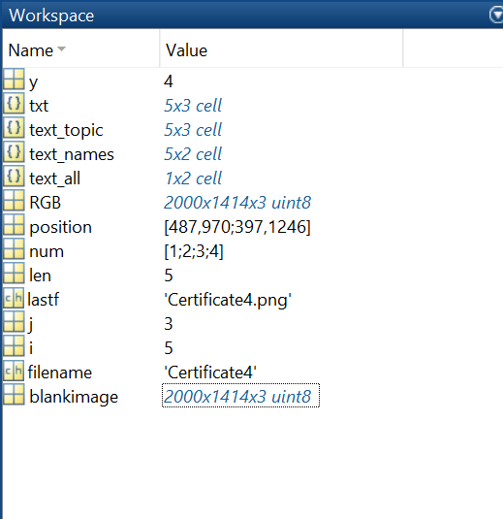

**Errors And Difficulties**

Typing mistakes were observed.

Using Image Processing tools were hectic.

Errors in input arguments were found due to being unfamiliar with new functions.

Alignment of the certificate details while inserting the text in the certificate was a lengthy process.

# CONCLUSIONS

Our certificate generation system successfully automates the creation of customized certificates using data from an Excel file. The system's user-friendly interface and robust functionality ensure efficient certificate generation, while its flexibility allows for easy customization of certificate designs. With satisfactory performance and reliability, the system presents a valuable solution for organizations and event organizers seeking to streamline the certificate creation process. Future enhancements could further improve the system's capabilities, but overall, it represents a valuable tool for optimizing efficiency and professionalism in certificate generation.

# References

https://youtu.be/Ju2yf2hT9NU?si=dXxyczNpHQSNkDxc https://chat.openai.com